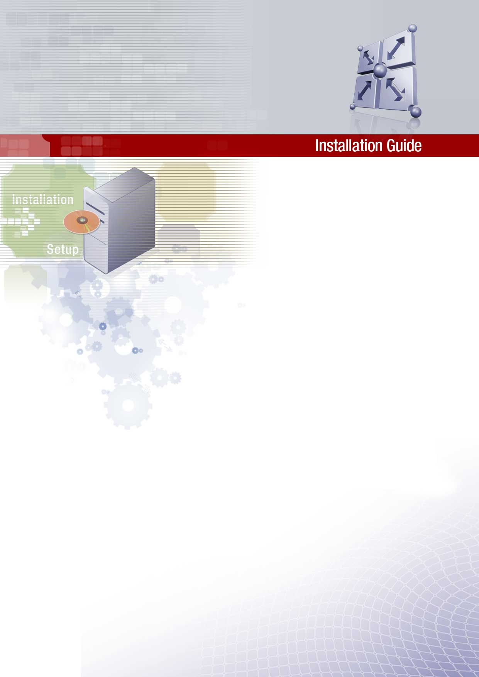
Cordys Build Framework
Version 1.0

© 2003 Cordys R&D B.V. All rights reserved.
The information in this document is confidential and may be legally privileged and is protected by copyright law and international copyright treaty. The information contained in this document is subject to change without notice. Cordys R&D B.V. does not warrant that this document is error free. No part of this document may be reproduced, stored or transmitted in any form or by any means, electronic or mechanical, for any purpose, without the express written permission of Cordys R&D B.V. Cordys R&D B.V. assumes no liability for any damage incurred, directly or indirectly, from any errors, omissions, or discrepancies between the software and the information contained in this document.
Cordys BCP, Cordys WCP, Cordys CPC, Cordys CenterCourt, Cordys Integrator, Cordys Orchestrator, Cordys Portal, Cordys BAC, Cordys for BaanIV, ACR Cockpit, Sales Cockpit, Customer Cockpit and Cordys logo are trademarks of Cordys R&D B.V.
All other trademarks mentioned here are trademarks or registered trademarks of their respective owners and should be noted as such. Any unauthorized use may violate trademark laws and may be subject to damages and penalties.
Contents
1. About Build Framework 5
1.1 Mission 5
1.2 Intended Audience 5
1.3 Prerequisites 5
1.4 How this guide is organized 6
1.5 Documentation Conventions 7
1.6 Abbreviations 8
2. Getting started 9
3. Installation Requirements 10
3.1 Recommended Hardware 10
3.2 Operating System 10
3.3 Software needs 10
4. Build Framework Overview 11
5. Build Server Setup 12
5.1 Installation of CruiseControl 12
5.1.1 Features 12
5.1.2 Build Loop 12
5.1.3 Installation 12
5.1.4 Creating Working Directory 13
5.1.5 Building web interface 14
5.1.6 Configuring multiple projects 15
5.2 Setting up CruiseControl 15
5.2.1 Creating new project 15
5.2.2 Starting CruiseControl 15
5.2.3 Reporting build status via email 15
6. Build Server Configuration 17
6.1 Configuration 17
6.2 Project Build file 18
6.3 Project Configuration file 18
6.4 Delegating Build File 21
6.5 Running Cruise as a Windows Service 21
6.5.1 Setting up 21
6.5.2 Running the service 22
6.5.3 Removing the Service 23

- About Build Framework

Mission

- An integrated and structured view of the project for the configuration engineer, build manager and the other team members.
- Standard platform and a development environment for the complete project for the entire team.
- Version control of the content types.
- An automated process to carry out builds (at scheduled times) together with basic verification tests done (unit tests) and notification of build status and changes in the build.
- Create a completely cooked distribution which can just be placed on a web site or a CD, so that testing can start right away.

Intended Audience
This document is intended for the configuration managers, development managers and builds engineers who are planning to integrate the working environment of their projects along with the build process so that it can run in an unattended mode. This document throws light on the continuous build loop process and explains in detail as to how one can build a great automated build management process.

Prerequisites
- Cordys ECX 1.3 or higher
- Web server such as Tomcat for publishing build results
- Eclipse IDE 2.1.1 or higher (or any other IDE such as Visual Studio)
- Cruise Control 2.1.3
- Version Control System like CVS or VSS

How this guide is organized
The Installation Guide is organized as follows:
Chapter 1, “About Build Framework”
Provides introductory information about the Cordys Build Framework.
Chapter 2, “Getting Started”
Provides details of the prerequisites for the Cordys Build Framework.
Chapter 3, “Installation Requirements”
Describes the hardware and software requirements for installing the Cordys Build Framework.
Chapter 4, “Build Framework Overview”
Describes the working of the entire framework .
Chapter 4, “Build Framework Setup”
Provides a step-by-step explanation to install Cordys Build Framework. This elucidates the installation and configuration of CVS and CC.
Chapter 5, “Build Server Configuration”
Describes the activities to be done on the Server side for the initial setup of Cordys Build Framework.

Documentation Conventions
Style Name | Example | Used For
Navigation | Browse to user → system → system administrator | Listing down the navigation steps from a menu or context menu or any standard windows navigation functionality.
Path | The install directory is /cordys/wcp/xmlstore/  Or, Styles sheets are stored in the folder styles | This style is used for depicting a path, which may include the folders, files and computer names or any of them individually.
Button | Click ok to generate tables or cancel to exit.  Or, click new icon for a new document | A button or icon is represented in this style. This is always in small caps.
Key stroke | Press the return key | This is used for a key on the keyboard
Method | Select the method getemployeeid and click on add to add the Method Set. Remove the unnecessary method sets using the remove button. | A method name is always depicted with this style; the case should be followed as per the name of the method.
Parameter | Type server Name when asked for server name | The parameter style is used to highlight the name of the parameter for which a value has to be entered.
Value | Type <wcp_server_1> when asked for server name | The style value is used for a sample value or instructed value for computer names, etc. This should be replaced by the user’s value excluding the < and > at the input field in the software.
Code text | <code> this is a sample </code> | This style is used for code text.

Abbreviations
Abbreviation | Description
BCP | Business Collaboration Platform
WCP | Web Collaboration Platform
CARS | Cordys Administrative Repository Service
ECX | Enterprise Collaboration Exchange
GA | General Availability
ISV | Independent Software Vendor
SP | Service Pack
CVS | Concurrent Versioning System
VSS | Visual Source Safe
CC | CruiseControl
IDE | Integrated Development Environment

- Getting started
Ensure that you have the following software. If you don’t have any of the same, then please refer to the specific installations guides and install the same before commencing the installation.

Sl. No. | Requirements | Y/N | If “NO” then this action
1. | Do you have Cordys Integrator 1.5 installed on the build server and client sides? |  | Install Cordys CARS and Cordys Integrator1.5.
2. | Do you have Source Control Tool – VSS or CVS? |  | Install CVS/ VSS.
3. | Do you have Tomcat installed on the build server? |  | Install Apache Tomcat.
4. | Do you have CruiseControl on the build server? |  | Install CruiseControl.

- Installation Requirements

Recommended Hardware
- Server Requirements
  - PIII with 512MB RAM*
  - 130 MB of free disk space
  - 800 x 600 pixels screen resolution with 256 colors. 1024 x 768 pixels with 32-bit color resolution is preferred.
- Client Requirements
  - PIII with 128MB RAM*
  - 130 MB of free disk space
  - 800 x 600 pixels screen resolution with 256 colors. 1024 x 768 pixels with 32-bit color resolution preferred.
(*) Memory requirements are dependent on various applications services that are configured to run on the computer.

Operating System
- Microsoft Windows NT server 4.0 with service packs 6 and IIS - 4.0.
- Microsoft Windows NT workstation 4.0 with service packs 6 and IIS 4.0.
- Microsoft Windows 2000 server with service packs 3 and IIS - 5.0.
- Microsoft Windows 2000 professional with service packs 3 and IIS - 6.0.
- Microsoft Windows XP Professional and IIS - 5.5.

Software needs
The following software has to be installed and configured before the installation of the Cordys Build Framework is started:
- Cordys ECX 1.3 or higher
- Source Control Tool – VSS or CVS
- Cruise Control
- Apache Tomcat

- Build Framework Overview

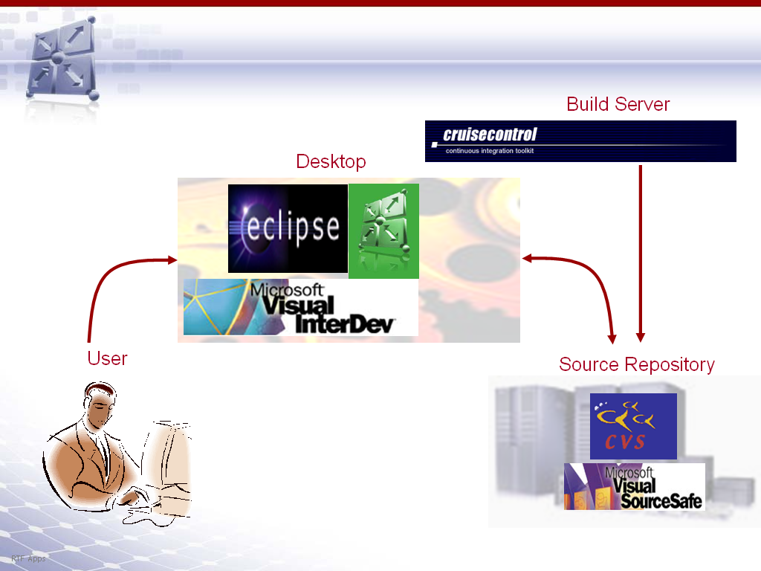

The above picture depicts the build environment where in the user works on his/her desktop and uses his own ECX rather than working on a centralized ECX. The user interacts with the build server via a source repository. In the build server, where the cruise control is running, the build happens automatically and is transparent to the user. Refer to the Developer guide for the setup on the user end.

- Build Server Setup

Installation of CruiseControl

Features
- Framework for continuous build process
- Configure multiple projects with a simple configuration xml
- Scheduler for build runs
- Email notification
- Support for source control - CVS, VSS
- Web interface to view build results
- Artifacts - a copy of the deliverables from each build
- Web-based Project Controller for forcing, pausing and resuming builds

Build Loop
The Build Loop is designed to run as a daemon process which wakes up at specific intervals as configured and attempts a build cycle. It checks the source control tool for changes to the code base, builds if necessary, and sends out a notification regarding the status of the build.

Installation
- Download the Cruise Control 2.1.3 from http://cruisecontrol.sourceforge.net.
- Unzip the jar to the required directory, referred to as INSTALL_DIR.
- Cruise Control is distributed as source files. Run the build script build.bat which compiles the sources, runs tests and creates a jar
INSTALL_DIR /main/dist/cruisecontrol.jar
- Run in the command prompt as
java -jar cruisecontrol.jar
Or use the scripts (cruisecontrol.bat/cruiscontrol.sh) in INSTALL_DIR/main/bin.
- "No config file" message indicates a successful CC installation.

Creating Working Directory
- Create the working directory under the INSTALL_DIR, referred to as WORK_DIR. The working directory is where cruise control keeps running. Create sub folders as
- WORK_DIR/checkout - CC checks out projects from CVS, to a subfolder with the project name.
- WORK_DIR/logs - CC will write its build reports into the corresponding project folder.
- WORK_DIR/artifacts - CC backups the output files from every build into a date tagged folder.
Best Practices


Keep separate folders for checkout, logs, artifacts, etc. This will help in scaling Cruise Control for Multiple Project Scenario.
For each project, create a subfolder with its name under each of these folders. Thus multiple projects can be managed effectively.

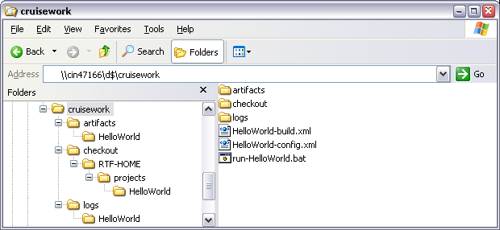
- Create the configuration file 'config.xml' in the working folder as
<cruisecontrol> </cruisecontrol>

- Run CC from this folder. CC will look for the file,'config.xml' and if it exists, displays the message "BuildQueue started". This indicates that CC has started up correctly.

Building web interface
The CC web reporting application needs to be built before it can be used. A properties file is to be added to the installation directory.
- Open the INSTALL_DIR/reporting/jsp directory.
- Create a new file called "override.properties", the properties in this file will be used to generate the Web.xml (deployment descriptor) for the web app.
# This should be the full path to your CruiseControl log directory.
user.log.dir=WORK_DIR/logs/TestProject
# This should be the path to your current build status file,
# expressed relative to the project's log directory.
user.build.status.file=buildstatus.txt
# This should be the absolute path to the directory where
# additional build artifacts are stored.
cruise.build.artifacts.dir=WORK_DIR/artifacts
- Generate cruisecontrol.war by executing "ant war" in the directory INSTALL_DIR/reporting/jsp.
- Copy the cruisecontrol.war file from the dist directory to the %TOMCAT_HOME%/webapps directory in the server.
- Browse to the APPLICATION_PATH/index.jsp. This page provides links to the ‘build results page’ for each project.
- Startup the server by going to the %TOMCAT_HOME%/bin directory and using the startup script. The cruisecontrol web application should deploy and you should be able to test it out by opening a web browser and going to http://localhost:8080/cruisecontrol/buildresults
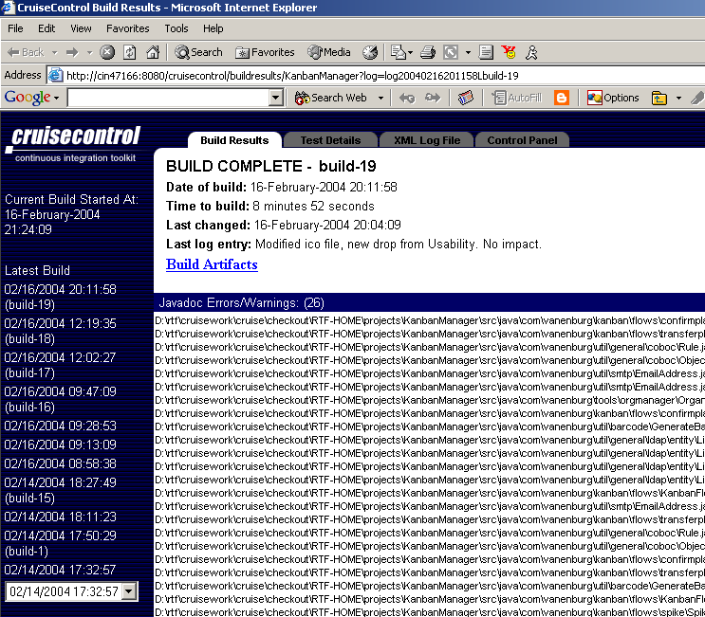

Configuring multiple projects
CC can be configured for the build of several projects to occur concurrently. The batch file for each project is to be kept running and the builds are taken for each of this project periodically as specified.

Setting up CruiseControl

Creating new project
Each project needs
- Batch file
- Configuration file
- Delegating build file

Starting CruiseControl
- Execute the batch file of the project to start the build process.
- If changes have been committed to the repository, a build will be created.
- Cruise build reports are stored as xml files in the WORK_DIR/logs/TESTPROJECT. Any file that ends with "log*build.?.xml" indicates a successful build, while other xml files indicate failures.
- After each build, web interface is updated with the status and email notifications etc mentioned in the <publishers> are done.

Reporting build status via email
The email functionality can be configured to send emails to one set of addresses on every single build (success or failure) with the <always>, and another set of addresses just on failed builds <failure>. To set this up, add the mail element to the <publishers> element:
<email mailhost="SMTP_HOST"
returnaddress="cruise@mydomain.com"
buildresultsurl= "http://localhost/cc/buildresults/MY_PROJECT_1"
skipusers="true" spamwhilebroken="true">
<always address="dev1@mydomain.com"/>
<always address="dev2@mydomain.com"/>
<failure address="failed-builds@mydomain.com"/>
</email>
If you also want individual committers to recieve email for all builds where they made changes, then set "skipusers" to false, and add a <map alias="cvsuser" address="cvsuser@mydomain.com"/> for each user. Alternatively, you can add an email map to the CVS module. Or, as a 3rd alternative, cruise can append a default suffix to the user name to derive an email address.

To get nicely formatted HTML mail HTML email publisher is used. Use <htmlemail > instead of <email>
<htmlemail css="INSTALL_DIR\reporting\jsp\css\cruisecontrol.css"
xsldir="INSTALL_DIR\reporting\jsp\xsl"
logdir="logs/MY_PROJECT_1">
</htmlemail>
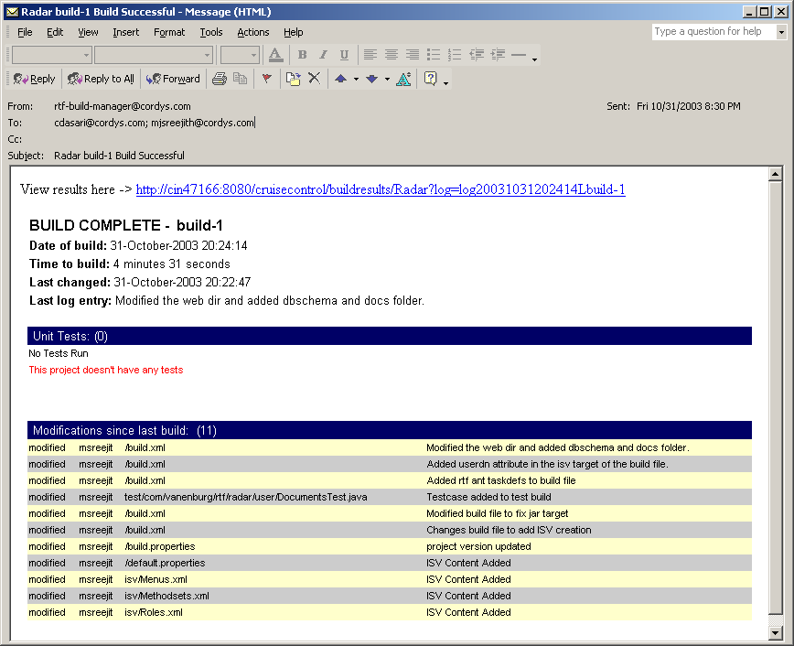

- Build Server Configuration
A machine is set exclusively for builds, with Cruise Control implemented as the build management software.

Best Practices
The source repository can be employed as the build server also. But it is better to have the source and build sever on separate machines.

Configuration
- Check out a project from CVS to a folder under WORK_DIR as HelloWorld.
- Create the batch, configuration and build files.

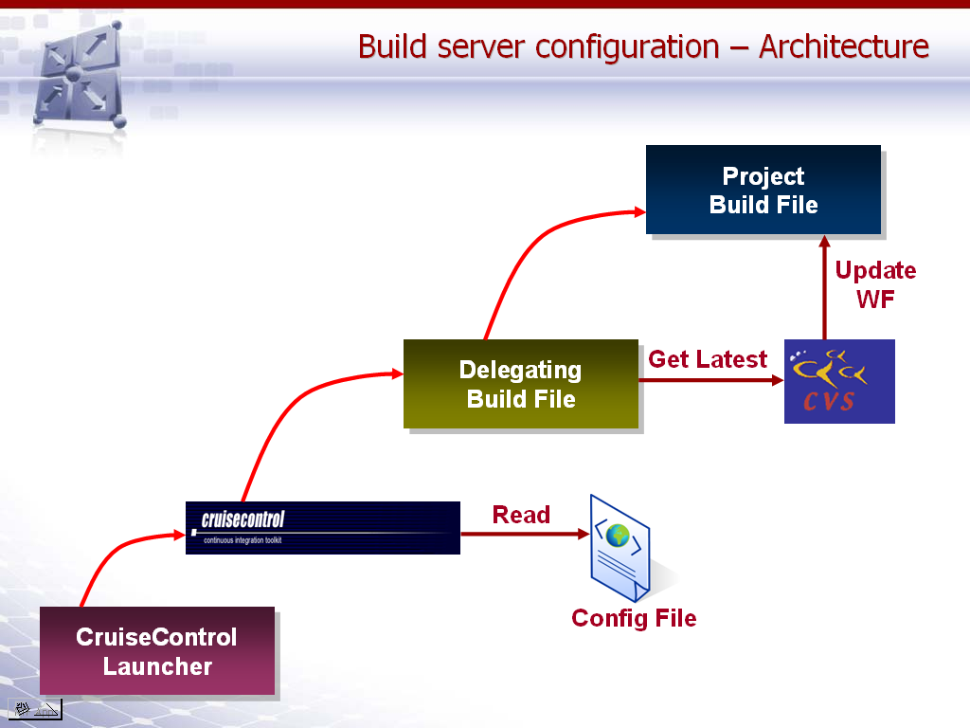

Project Build file
The batch file is run to start the build loop for this project. This sets the necessary classpath, launches the CC, passing configuration details via a specified file. This file also assigns a port for this project that can be controlled via a web based project controller.
@ECHO off
REM For running Cruise Control
ECHO Starting Cruise Control Build Loop for HelloWorld...
D:

cd "D:\rtf\cruisework\cruise"
java -cp D:\rtf\cruisework\dashboard\dashboard-props.xml;
D:\rtf\cruisework\dashboard\dashboard-server-1.0.2.jar;
D:\rtf\cruisework\ant\rtftasks.jar;D:\rtf\cruisework\ant\ant.jar;
D:\rtf\cruisework\ant\optional.jar;D:\rtf\cruisework\ant\junit.jar;
C:\Progra~1\Cordys\WCP\activation.jar;
C:\Progra~1\Cordys\WCP\jldap.jar;
C:\Progra~1\Cordys\WCP\jms.jar;
C:\Progra~1\Cordys\WCP\ldapjdk.jar;
C:\Progra~1\Cordys\WCP\mail.jar;
C:\Progra~1\Cordys\WCP\wcp.jar;
C:\Progra~1\Cordys\WCP\wcp-iis.jar;
C:\Progra~1\Cordys\WCP\wcp-mdk.jar;
C:\Progra~1\Cordys\WCP\xerces.jar;
C:\Progra~1\cruisecontrol-2.1.3\main\dist\cruisecontrol.jar;
C:\Progra~1\cruisecontrol-2.1.3\main\lib\jdom.jar;
C:\Java\j2sdk1.4.1_02\jre\lib\rt.jar;
C:\Java\j2sdk1.4.1_02\lib\tools.jar
CruiseControl
-port 1024
-projectname HelloWorld
-configfile HelloWorld -config.xml
-lastbuild 20030307080000
-label HelloWorld -1-0

Project Configuration file
The configuration file config.xml specifies
- Project name
- Local CVS folder to be monitored for changes
- Delegator ant task for the project
- Scheduling details for the build
- Log file location
- Post build operations like updates, mails
- Plug-ins needed additionally such as ‘HTMLemail’,’ labelincrementer’, ‘pause’.

<cruisecontrol>
<project name="HelloWorld" buildafterfailed="false">

<!-- Bootstrappers are run every time the build runs,*before* the modification checks -->
<bootstrappers>
<currentbuildstatusbootstrapper file="logs/HelloWorld/buildstatus.txt"/>
</bootstrappers>

<!-- Defines where cruise looks for changes,to decide whether to run the build -->
<modificationset quietperiod="120">
<cvs localworkingcopy=
"D:\rtf\cruisework\cruise\checkout\RTF-HOME\Projects\HelloWorld"/>
</modificationset>

<!-- Configures the actual build loop,how often and which build file/target -->
<schedule interval="120">
<ant buildfile="HelloWorld-build.xml"
target="build"
uselogger="false"
usedebug="true">
</ant>
<pause starttime="1900" endtime="2359"/>
<pause starttime="0000" endtime="0659"/>
<pause day="saturday" starttime="0000" endtime="2359"/>
<pause day="sunday" starttime="0000" endtime="2359"/>
</schedule>

<!-- directory to write build logs to -->
<log dir="logs/HelloWorld" encoding="ISO-8859-1"/>

<!-- Publishers are run *after* a build completes -->
<publishers>
<currentbuildstatuspublisher file="logs/buildstatus.txt" />
<artifactspublisher
dir="logs/HelloWorld" dest="D:\rtf\cruisework\cruise\artifacts\HelloWorld"/>

<HTMLemail mailhost="ex-nl-u0.vanenburg.com"
returnaddress="mjsreejith@cordys.com"
returnname="RTF Build Manager"
buildresultsurl=http://cin47166:8080/cruisecontrol/buildresults/HelloWorld
xsldir="C:\Progra~1\cruisecontrol-2.1.3\reporting\jsp\xsl"
logdir="D:\rtf\cruisework\cruise\logs\HelloWorld"
css="C:\Progra~1\cruisecontrol-2.1.3\reporting\jsp\css\cruisecontrol.css"
charset="ISO-8859-1"
spamwhilebroken="true" skipUsers="true">
<always address="buildmasters" />
<success address="managers" />
<map alias="buildmasters" address="mjsreejith@cordys.com,agattu@cordys.com" />
<map alias="managers" address="cdasari@cordys.com" /> </HTMLemail>
</publishers>
<dateformat format="dd-MMMM-yyyy HH:mm:ss"/>

<plugin name="labelincrementer" classname="net.sourceforge.cruisecontrol.labelincrementers.CVSLabelIncrementer"/>
<plugin name="pause" classname="net.sourceforge.cruisecontrol.PauseBuilder" />

<plugin name="HTMLemail" classname="net.sourceforge.cruisecontrol.publishers.HTMLEmailPublisher" />
</project>
</cruisecontrol>

Advanced

The "buildafterfailed" property tells cruise if it should keep on trying to build, even if the last time failed and there have been no changes.
The <currentbuildstatusbootstrapper> element tells cruise the name of a file where notes about current activity is written. This file is required by the web application. The file is to be placed in the project logs directory. This bootstrapper writes "Current Build Started At: *date*" to this file.
The <modificationset> element configures how cruise checks for VVS/CVS changes, before running the build. Cruise checks for changes in its local working copy of the module checked out earlier.
The "quietperiod" attribute tells cruise not to try to build while the CVS repository is being actively updated. Instead, cruise waits until it sees a period of quiet in the repository, before doing a build. So if you're committing files individually to CVS, cruise will wait until you've finished, as long as you don't take longer than the quietperiod between commits.
The <schedule> element sets up the build-loop for the project, with the "interval" attribute telling cruise how many seconds to sleep in between builds. The pause elements are to stall the Cruise Control from running builds.
The <ant> element tells cruise which ant build file to run, and which target. The uselogger and usedebug elements together tell cruise not to write Ant debug statements to the build logs.
The <log> element tells cruise where to put the log reports output of a Cruise build.
The <publishers> element configures actions to perform after the build completes, such as sending emails, and copying files
<currentbuildstatuspublisher> writes a status message "Next Build Starts At: *time*" to buildstatus.txt.
With the "interval"(60) and "quietperiod"(10) above, cruise will check for modifications in CVS every 60 seconds. If modifications were made in the 10 seconds before the check, cruise will wait until a 10 second window with *no* changes is found. Once this happens, cruise will kick off the ant build.
<modificationset> configuration to work with VSS is

<modificationset quietperiod="5">
<vss ssdir="\\Vssserver\vss\win32\"
vsspath="/Software/Source/portal"
login="username,password"
serverpath="\\Vssserver\vss" />
</modificationset>

Advanced
ssdir is the path (local or network) to your VSS Server ss.exe file (not your VSS client).
vsspath is the location of your project in the VSS source tree
serverpath is the path (local or network) to your VSS Server srcsafe.ini file.

Delegating Build File
The delegating builds file checks out the latest contents of the project from CVS and calls the build file of the project. The build file is also being checked out from repository, so the latest version is being run.
<!-- Delegating build script, used by cruisecontrol to build.-->
<project name="build-HelloWorld" default="build" basedir="checkout\RTF-HOME\projects\HelloWorld">

<target name="build">

<!-- Login to CVS -->
<cvs command="login" cvsRoot=":pserver:buildmanager:<password>@srv-ind-crtm1:d:/rtf/repository"/>

<!-- Get the latest from CVS -->
<cvs command="up -d -P" />

<!-- Call the target that does everything -->
<ant antfile="build.xml" target="dist"/>
</target>
</project>
ADVANCED
Note that the basedir is set to the checked out project . The <vssget> is to be run instead of <cvs> command for the VSS source repository.

Running Cruise as a Windows Service

Setting up
The first step is to obtain a service connector that hosts Java applications. The Java Service tool from http://www.alexandriasc.com/software/JavaService/index.html ideal as it was easy to host Cruise Control using it. The steps are:
- Download and unpack the JavaService zip file.
- Rename JavaService.exe to CruiseControlService.exe. The Java Service guide suggests you should copy and rename for each java application you want to run as a service. This allows you to easily spot the Cruise Control service in the Windows task manager.
- Place CruiseControlService.exe in the CruiseControl\bin directory
- In the same directory make a copy of cruisecontrol.bat and name it cruisecontrolservice.bat
- Edit cruisecontrolservice.bat and change the line:
set EXEC=java -cp %CRUISE_PATH% CruiseControl %*

set EXEC=CruiseControlService.exe
-install "Cruise Control" %JAVA_HOME%\jre\bin\hotspot\jvm.dll -Djava.class.path=%CRUISE_PATH%
-start CruiseControl
-params %*
-out %CCDIR%\service_out.log
-err %CCDIR%\service_err.log
-current %CCDIR%
- The above settings for the -out, -err and -current switches can be changed to suite your needs
You can choose to use another JVM such as %JAVA_HOME%\jre\bin\classic\jvm.dll
-current must point to the directory in which you have run the Cruise control project prior to starting the service. See below for details.

Running the service
You must have run CruiseControl at least once from a DOS window to ensure that the project state (specifically the build label and last build date) has been saved to disk. The -current switch must point to the location where you ran the initial Cruise Control project.
Install the service by running the batch file with appropriate switches
cruisecontrolservice -configfile <name> [-port <port>]
Go to the Windows Services panel and locate the service "Cruise Control" and ensure that the service is running under the correct user account.
Set the service to "Automatic" and start it.
Check that the service is running correctly by looking at the output and error log files. The output file should have the same content that you see Cruise Control write to a console window.
Stop the service and restart it and recheck the logs to ensure that everything is still working.
That should be it. Your CruiseControl project should automatically start running whenever the machine is turned on. If you are having trouble the logs should help.

Removing the Service
You will need to do this if you got the installation values wrong and you need to reinstall the service with new values, or you decide this doesn't work for you and you want shot of it.
Issue the DOS command (from CruiseControl\bin):
CruiseControlService -uninstall "Cruise Control"

